BEEKEEPING 101
Lincoln Land Beekeepers Beginning Bee Class Registration
(Meetings are held on 2nd Thursday each month at Sangamon Co. Farm Bureau Bldg) Questions? Call 217-652-6517
Limited Seating for training, so get your registration in!

Training Dates: Sat. April 4, 2026, from 9 am-4 pm
Thursday, April 9, 2026, at 7 pm (Regular Bee Meeting Night)
April 11, 2026, from 9 am-4 pm
Sangamon Co. Farm Bureau
2631 Beecher Court
Springfield, IL (behind IHOP on Dirksen)

$95 check made to Lincolnland Beekeepers (CO Honey Creek Farm) with application to101 Trillium Ln, Spfld, il 62707 or credit card sent to Lincoln Land Beekeepers, please email application to tressa.hoffman@yahoo.com

Website is: www.lincolnlandbeekeepers.org

facebook page is: www.facebook.com/groups/Lincolnlandbeekeepers

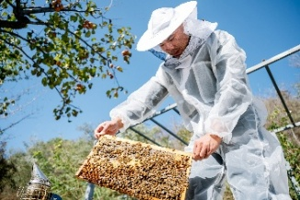
*Learn how to manage your hive and harvest honey
*Use tools and equipment
*Promote bee health
*Seasonal Care
*Mentoring
Fun Door Prizes
Use the QR code to prepay using a credit card
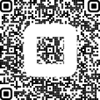

Student Name_______________________________________Gender__________Birthdate_______________
Address_________________________________________________________________________________
Phone____________________Previous Bee Experience_____________________________________________

Cost: $95 – Includes Beginning Beekeeping Book, Year of Club dues(LLBK), membership. Bee Packages will be made available for purchase
Questions/Comments-

